**A Proposal for a Cluster Hire in Ecosystem Genomics**

Russell Monson (School of Natural Resources and the Environment), Rachel Gallery (School of Natural Resources and the Environment), Raina Maier (Soil, Water and Environmental Science), Julia Neilson (Soil, Water and Environmental Science), Betsy Arnold (School of Plant Sciences), Rod Wing (School of Plant Sciences), Mike Sanderson (Ecology and Evolutionary Biology), Scott Saleska (Ecology and Evolutionary Biology), Bryan Heidorn (School of Information), Nirav Merchant (iPlant, BIO5, ARL)

***What is Ecosystem Genomics?*** ‘Ecosystem Genomics’ is both a ***new scientific discipline*** and a ***nexus for coalescing UA strengths*** in environmental, agricultural and biological sciences with those in genomics, cyberinfrastucture, and information sciences to address the multiple grand challenges affecting the vitality and sustainability of Earth’s environmental support systems. *Studies in ecosystem genomics are capable of providing solutions to some of society's greatest threats, including those to food security, climate instability, ecosystem integrity, chemical pollution and emergent diseases in the health, agricultural, and veterinary sciences.*

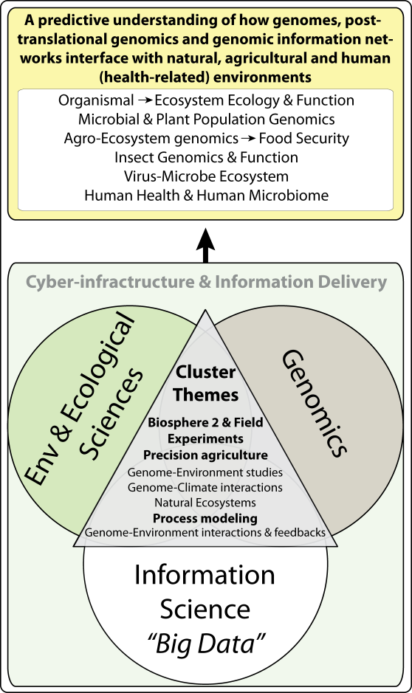***The Opportunity at the University of Arizona.*** The University of Arizona is recognized as a world leader in computational biology and genomic sciences. These areas have been well-developed through the iPlant Collaborative, the Biomedical Informatics Initiative in the Arizona Health Sciences Center, the IGERT program in genomics, and the Arizona Genomics Institute in BIO5. To a large extent, these initiatives are aimed at elucidating genotype-to-phenotype connections – in other words, discovering the genetic basis for organism form and function, utilizing the human genome to treat human disease, and improving crop productivity. Together, they have provided the UA with 'big-data' and 'big-computing' capabilities. However, they also have limited potential because of their focus on discipline applications – there is a need to expand their potential to support cross-disciplinary education. We, at UA, have the opportunity to put in place an intellectual synergy capable of discovering how genomes control the 'behavior' of whole ecosystems – e.g., natural ecosystems, agro-ecosystems, and the human-body ecosystem – and how ecosystems influence the translational aspects of organismal genomes. ***We have the opportunity to convert 'big-data' initiatives into 'smart-data' initiatives.***

Imagine the ways we could change the world if were able to understand and manage ecosystems from the first principles of genetics – from the foundation of their function. Agronomists could suppress the emergence of crop diseases, enhance crop stress tolerance and renovate degraded ecosystems by managing and engineering genome-environment or genome-genome interactions. Biogeochemists could accurately predict how assemblages of organisms accelerate or retard greenhouse gas emissions. Environmental chemists could avert threats to health and food production by exploiting an understanding of how genomes interact with pollutants. Physicians could develop treatments of complex diseases, such as diabetes and asthma based on the environment-genome interactions. *In addition to creating a new discipline at the UA, the Cluster Hire that we propose will form a central hub capable of attracting and connecting several existing units and initiatives. Here we describe the positions and how they would act as synergistic catalysts within UA.*

***Positions Proposed for the Cluster Hire.*** We propose five positions that would bridge programs in the Arizona Health Sciences Center and BIO5, which focus on information theory and translational genomics, research initiatives in the Biosphere 2 and within CALS and COS, which focus on the natural sciences – from organisms to ecosystems, and the newly-formed School of Information in CSBS, which focuses on big-data and big-computing.

**1. Soil-microbe genome interactions:** Nutrient-cycling and plant growth-promoting activities of soil microbial communities are critical to plant survival, soil quality and ecosystem health. This position would support a cross-cutting microbial ecologist focused on biogeochemical cycles, reclamation/re-vegetation efforts, plant biology, and fundamental knowledge regarding the evolution, metagenomics, and ecological assembly of microbial communities.

**2. Plant-microbe genome interactions:** We are ready to discover and utilize plant and microbial symbioses to optimize health, productivity, plant stress tolerance, and the nutritional quality of crop plants in marginal and arid ecosystems (a probiotic approach). This position would support a plant or microbial scientist interested in the use of translational genomics to create (engineer) novel symbioses that improve plant stress resistance.

**3.** **Organismal genome-environment interactions:** Some of the most challenging issues in human and agricultural disease have a common foundation in understanding gene-environment interactions, including epigenetic effects. In other words, what is the ecosystem context for understanding genome-environment interactions? This position would support a theoretical or experimental genomicist taking on the challenge of combining and analyzing the complex datasets generated by genetic and environmental analysis at the organismal scale .

**4.** **Agro-ecosystem genomics:** Agro-ecosystem genomics offers a new paradigm shift in how 21st Century plant breeders and molecular geneticists will create the next generation of green super crops – those that reduce environmental footprints (i.e., less water, fertilizer and pesticides) and are higher-yielding and more nutritious. This position would support an scientist working with microbial, plant, and insect genomics using high-throughput analytical techniques, translational genomics, and phenotyping to design higher-yielding agricultural ecosystems.

**5.** **Genome- and big data-enabled development of ecological theory and models:** Genomic controls at small scales affect ecological, evolutionary and ecosystem processes at large spatiotemporal scales, but the search for pattern in these relationships requires new forms of scaling theory. This position would support a person studying the processes of synthesis – how to use large data bases from multiple streams, including genomics, climate monitoring, satellite imagery, species distributions, phenotypic trait distributions, community composition, and biogeochemistry to discover fundamental patterns in causal relations across broad spatiotemporal scales (from genes to the entire earth system) – ***in other words, the process of getting from 'big-data' to 'smart-data'***.

***Contributions to Education in the Colleges and to the Development of ABOR Metrics .*** We will focus recruiting efforts on faculty members who have a record of enthusiastic participation in undergraduate teaching and research. We will include ABOR metrics as stated parameters of the positions during recruitment, including expected contributions to unit success in awarding bachelors, masters and Ph.D. degrees, in increasing student credit hour production through the development of new courses, and in enhancing major retention rates through the development of undergraduate research opportunities. We will especially emphasize the development of new online courses to serve students and stakeholders statewide and beyond.

***Relation of the Cluster Hire to the AEGIS ABOR Initiative.*** The Cluster Hire that we propose builds on our past success in developing a tri-university (UA, ASU, NAU) project, funded by the Arizona Board of Regents in 2013, entitled the Arizona Environmental Grid Infrastructure Service (AEGIS). Through this effort we created hardware, software, and training materials to enable researchers at all three universities to share and analyze large data sets. We are now in a position to accommodate new faculty hires capable of using the network and expanding it toward a next-generation model for iExtension in which genomic and environmental information can be combined for use by stakeholders to facilitate the adaptation or enhancement of crops, ecosystem conservation, and the cure of human and agricultural diseases (by elucidating the 'ecosystem of disease').

***Relation of the Cluster Hire to the iBiosphere Initiative and NSF STC Proposal Development.*** The foundation for a Cluster Hire in ecosystem genomics emerged from the iBiosphere Working Group that was convened in 2012 at the request of then-Associate VPR Andrew Comrie, and Deans Shane Burgess (CALS) and Joaquin Ruiz (COS). In creating the iBiosphere concept, a group of nine faculty members from six colleges developed a strategic plan for enhancing interfaces among the natural sciences, information sciences and social sciences, with a primary nexus being 'big-data' and 'big-computing'. The iBiosphere initiative served as the foundation for WEES-provided seed funding of a UA Ecosystem Genomics Institute (EGI), and development of an NSF Science and Technology Center (STC) proposal on the topic of Ecosystem Genomics. In the STC proposal we address the challenge of bridging the gap between genomic information and ecosystem processes. It is too early to count on funding for the STC initiative (we will know by March 2015 if we make it to the next round). However, if funded, the STC would bring up to $50 million dollars over ten years to the UA and would go far toward creating recruitment incentives for top-notch faculty hires. We are a talented and persistent group, and we make the case that it is a worthy venture to invest in hires in ecosystem genomics to enable this type of STC in the future.

***Relation of the Cluster Hire to the iPlant Collaborative, Biosphere 2, and the Critical Zone Observatory.*** With its focus on 'big-computing' capacity, large environmental databases and algorithm development, the iPlant Collaborative is ideally suited to attract faculty hires in plant, animal and microbial genome biology. In the ecosystem sciences, the Biosphere 2 offers as an attractive, novel, and valuable asset in which to conduct experiments. Several members of our team are currently planning to establish a multi-year experiment on the relations between the *Arabidopsis* genome and the assembly of specific microbial and plant metagenomic communities as part of the Land Evolution Observatory (LEO) at Biosphere 2. The NSF-funded Critical Zone Observatory (CZO) offers a third incentive to attracting potential hires. The CZO was designed to include soil and water genomic components. Among iPlant, the Biosphere 2 and the CZO, we have unique research opportunities at the UA that could be used as incentives for faculty recruitment.

***Relation of the Cluster Hire to the Honors College.*** The discipline of ecosystem genomics is an emerging field composed of advanced topics involved with genetics and big-data science, as well as interfaces with environmental science, agriculture and health. These topics, especially as applied to solving the Grand Challenges to society, such as food security, adaptation to climate change, and sustainable agriculture in marginal environments, are ideally suited for the development of Honors College courses. We will partner with the Honors College to develop innovative courses with unconventional pairings between faculty from the Cluster Hire and faculty from the Honors College to create courses with novel world views. For example, a course that pairs a genomicist with a faculty member in ethics or international relations could produce a novel perspective, aimed at pre-health majors, on the potential use of genomic technology to resolve international challenges. Through this type of curriculum development, we will train a new generation of global enviro-genomicists – students capable of enabling big-data, genomic information to resolve threats to environmental and societal sustainability.

***Relation to of the Cluster Hire to Never Settle.*** In designing this Cluster Hire initiative we have enabled cross-college collaborations that sit solidly on two Priority Areas: Environment and Big-Data Informatics. We have partnered with the Honors College to enhance student ***engagement*** beyond the traditional modes of departmental curricula. We have emphasized ***innovation*** in developing the opportunity to create a new discipline – environmental and ecosystem genomics. We have envisioned a means of creating a new form of iExtension for ***partnering*** with regional stakeholders. We are keen to create ***synergies*** to develop and exploit new products with financial potential, new strategies for translational manipulation of genomes, and new types of probiotic 'ecosystem engineering' for adaptation to climate change and cures for complex disease. We also note that our proposal aligns closely with the Strategic Priorities Faculty Initiative (SPFI) to attract outstanding faculty to advance research, teaching, and service at the nexus of biology, informatics, biotechnology, and sustainability in order to serve the needs of society. ***Our proposal will be especially effective in organizing the aims of the SPFI around linkages among intellectual communities that have heretofore not been particularly well connected at the UA – including those in the environmental sciences, information sciences, agricultural sciences and health sciences.***

***Estimated Financial Requirements.*** In accordance with the call for proposals, we would focus on recruitment of early- (recently tenured) and mid-career faculty. It is anticipated that we will need to offer salaries (nine-month) in the range $100 – 150 K. The start-up costs for each position are likely to be in the range $600 K - $900 K; given the need to build groups in analytically-based, laboratory science. It should be possible to develop the cluster with phased start-up packages given that most of the hires will, at least partially, move laboratories and instruments from previous positions. We encourage the use of pooled analytical laboratories and buy-in to existing facilities (such as those that exist at Biosphere 2, iPlant, the Arizona Phenotyping Network, and within the CZO).

***The Hiring Plan and Strategy to Develop a 'Sense of Program' with Long-term Potential.*** We will target sole candidates and encourage the formation of self-nominated clusters. Once recruited, it will be imperative to establish institutional alcoves to nurture a new community, composed of new hires and existing faculty, and sustain a 'sense of common program'. Toward this end, we will work with inter-college units, such as BIO5 and the Honors College, and UA’s new Ecosystem Genomics Institute to create opportunities for seminar series and cross-cutting courses. With the seed of an ecosystem genomics team in place, we will be in a position to redirect the momentum of the current NSF IGERT in genomics into a new training program aimed to address Grand Challenge synergies in environmental, computational, and information-science. We expect the development of collaborative proposals to serve as an important means of creating cohesion within the group. The positions that we have described are not yet targeted to any specific Schools or Departments. During the recruitment phase, we will work with the hires to achieve an ideal match between their interests and those of the university to optimally distribute their impact and opportunity for success. We have not yet approached specific candidates, as this seems premature given the unsettled outcome of the competition. However, in order to provide a sense for where we might begin our recruiting efforts, we direct reviewers to the Institute of Genomic Biology at the University of Illinois (<http://www.igb.illinois.edu/>), the University of California, Davis Genome Center (<http://genomecenter.ucdavis.edu/people/faculty/>), the Ecological Genomics Institute at Kansas State University (<http://ecogen.ksu.edu/people.html>), and the Duke Center for the Genomics of Microbial Systems (<http://microbialgenomics.mgm.duke.edu/faculty>).